**Installing e(fx)clipse**

In Eclipse -> Help -> Install new software

Eclipse does not know about the location of the e(fx)clipse p2 repository so you need to add the repository as a software site. The address is: <http://download.eclipse.org/efxclipse/updates-released/1.2.0/site>

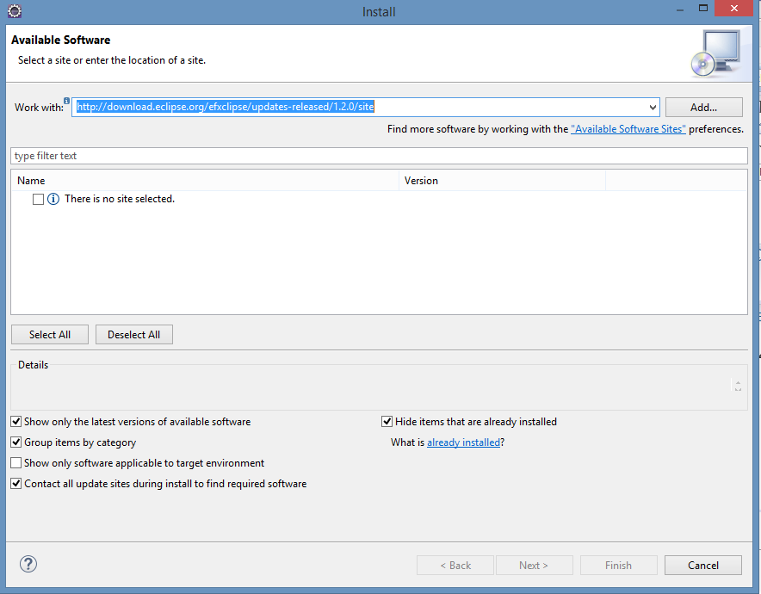

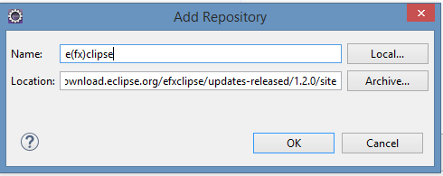

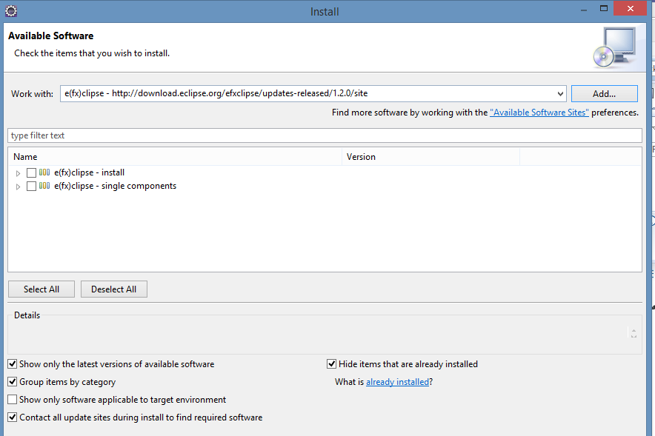

In the tree of installable features, check only the entry corresponding to your release:

* e(fx)clipse - IDE

Also, make sure the "Contact all update sites during install to find required software" is checked.

You may, however, install the FX Runtime feature into your IDE but we strongly recommend composing your own target platform.

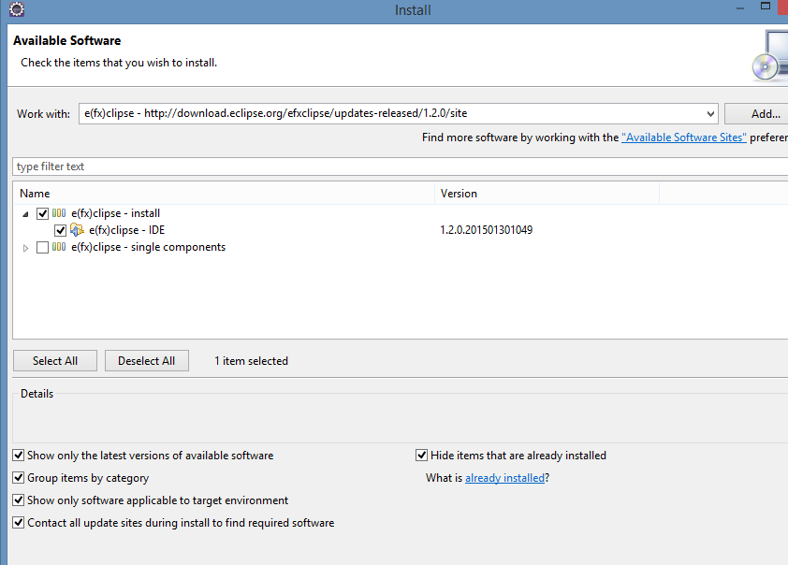

Select Next

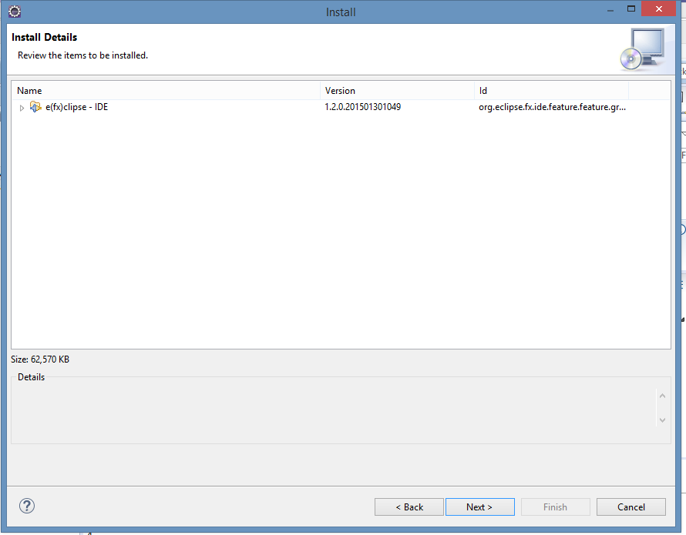

Select Next

Accept the terms of the licensing agreement

Select Finish

When requested, restart Eclipse.